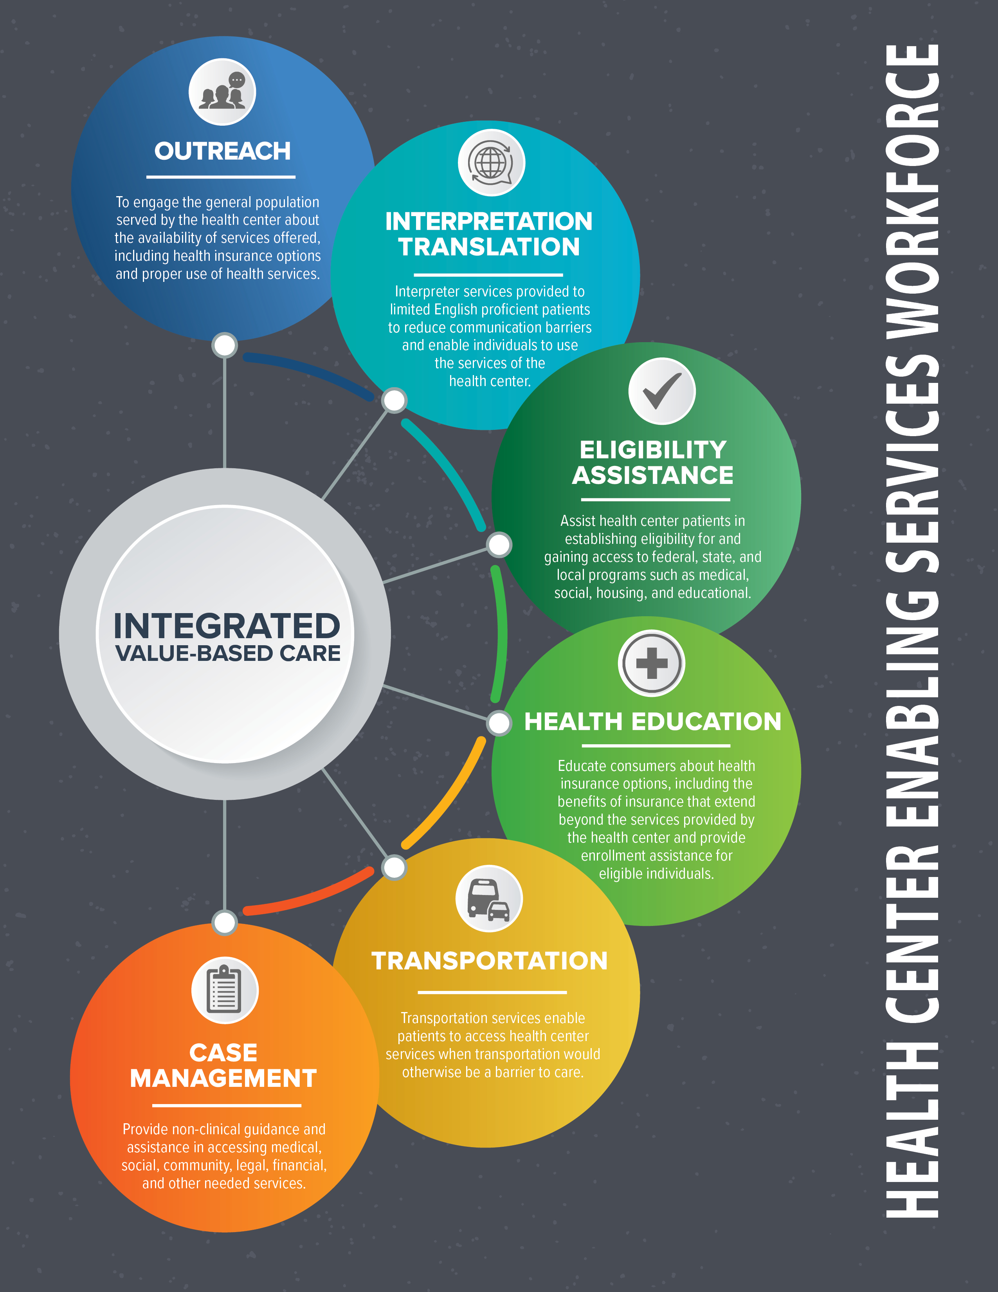

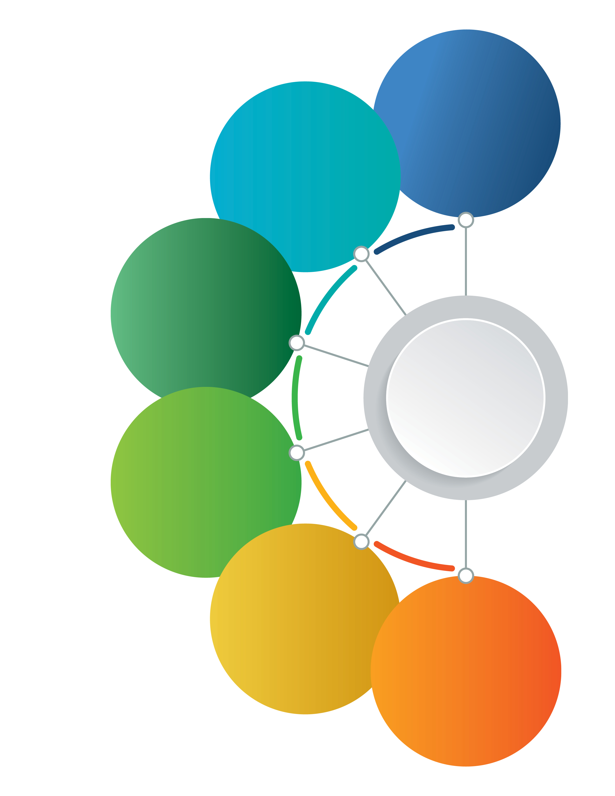
Enabling services are non-clinical services that increase access to health care and improve health outcomes for patients and communities. Enabling services at community health centers (CHCs) include outreach, language interpretation, eligibility assistance, health education, transportation, and case management. Enabling services are an increasingly important way that health centers advance the Quadruple Aim. By focusing on the holistic health of the patient and care coordination, health outcomes are improved on a wide range of clinical measures. Enabling services such as case management and transportation access increase access to preventive health services, which reduces long-term costs through the reduction of ER visits and effective chronic disease management. When resources are expanded, providers’ work life is improved and patients’ satisfaction improve. The end results support and iterate each other.

Below are the Quadruple Aim categories and examples of the ways in which integrated value-based care enhances patient experience, improves population health, reduces costs, and strengthens care team well-being. Please feel free to edit these examples to best fit the audience you serve. Sources for the data are provided.
ENHANCE PATIENT EXPERIENCE
Through comprehensive Outreach & Enrollment (O&E) services, CHCs can enhance patient experience, improve population health, and reduce costs. By investing in O&E, CHCs can reduce the number of uninsured patients, increase patients covered by Medicaid, increase total patients, and increase total gross revenue. With this extra revenue, CHCs can invest in quality and clinical initiatives to help improve patient health outcomes. For detailed examples, see the NACHC Outreach & Enrollment Case Studies.
IMPROVE POPULATION HEALTH
Community Health Workers (CHWs) provide health services and interventions to individuals and entire communities that include health education, advocacy, social support, language interpretation and translation, and more. Through CHW programs, CHCs can see cost savings, increased patient outcomes, and fewer emergency health care treatments. Check out the MHP Salud Brief Report on programs in Ohio and New Mexico that yielded such results.
REDUCE COSTS

Studies show that incorporating enabling services into health center practices can have significant return on investment (ROI) for the organization. For example, enrolling self-pay, uninsured patients into insurance coverage creates reimbursable visits that are beneficial to both the health center’s bottom line and its ability to care for its patients and expand its clinical and social programs. Enabling services also help reduce health disparities, cultural and linguistic barriers to care, and overall costs to the health care system. For research on how community health centers have used enabling services to reduce costs and increase the timeliness of care, see this article from NCBI.
STRENGTHEN CARE TEAM WELL-BEING
Enabling services play a role in creating Patient-Centered Medical Homes (PCMHs), a paradigm which emphasizes the continuous patient-provider relationship, holistic and preventive care, and the integration of technology that assists in wrap-around services. PCMHs reduce health disparities for minorities, address social determinants of health, and offer non-clinical health services. Enabling services play a large role in the latter, since PCMHs service the entirety of an individual’s health needs, including enrollment assistance, health education, case management, and more. Check out this fact sheet on The Role of Enabling Services in PCMHs.

Additional Resources:

NCBI: Use of Enabling Services by Asian American, Native Hawaiian, and Other Pacific Islander Patients at 4 Community Health Centers
AAPCHO: Impact-of-Enabling-Services-Utilization-on-Health-Outcomes
AAPCHO: Toolkit-ES_Data_Collection_Implementation_Packet_2005

Acknowledgement/Disclaimer
The information provided in this document is designed to provide helpful information regarding health center enabling services. This document is the outcome of an outreach and enabling services project in collaboration with Community HealthCare Association of the Dakotas, Community Health Association of Mountain/Plains States, Health Center Association of Nebraska, National Association of Community Health Centers, and based on input from various Primary Care Associations. Examples listed may have been customized by the author(s) other than the originators, and do not necessarily reflect the views of the organizations involved in the collaboration.

