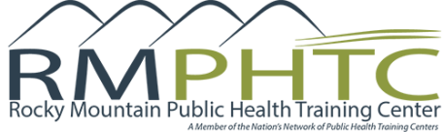
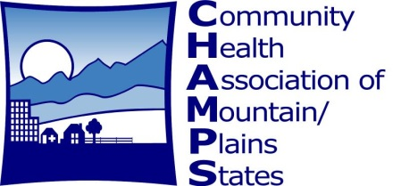
CARE COORDINATION
STRATEGIES FOR
DIABETES MANAGEMENT
About this Learning Community
Community Health Association of Mountain/Plains States (CHAMPS) is partnering with the Rocky Mountain Public Health Training Center (RM-PHTC) to develop and launch an interactive ECHO learning series to improve diabetic patient management in Region VIII Community Health Centers (CHCs). In this series, health center care coordination professionals will develop key skills and strategies and will learn about resources to support and engage patients with diabetes in their own care.

Dates:
August 1 – August 29

Days of the Week:
Tuesdays

Time:
11:30AM – 12:30PM Mountain Time
-
12:30PM – 1:30PM
Central Time

Cost:
Participation in this ECHO learning series is FREE for Region VIII Community Health Centers (CHCs)

- August 1 Diabetes Nutrition 101
- August 8: Identifying and Monitoring Patients
- August 15: Patient Motivation
- August 22: Tools to Support Behavior Change
- August 29: Building a Medical Neighborhood

Audience: This five-part series is intended for those coordinating the care of patients with diabetes at Region VIII Community Health Centers (CHCs). This may include case managers, care coordinators, patient navigators, etc., or those health center staff that oversee these roles. Participating health centers are not required to have a care coordination program specific to Diabetes Management. However, the series curriculum will focus on diabetes as an example of chronic disease management.

ECHO Learning Community participants are encouraged to attend all five sessions. Participants will need a computer with a webcam to log onto a live video conference meeting platform where they will see, hear, and interact with content experts and other participants in the learning community. Each participant, even those attending from the same health center, must register as an individual.
Register Now!
CHAMPSonline.org/events-trainings/distance-learning/projectecho
Questions? Contact Jen@CHAMPSonline.org.

