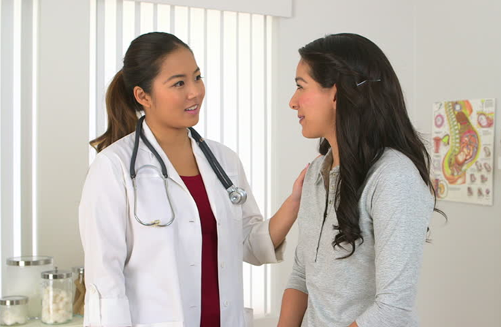  Women’s  Wellness  18-49 years of age  How to use this resource:  This document is intended to help you prepare for your Women’s Wellness Visit. Using this tool, you can write down questions you have for your care team, think about your health priorities, and, together with your care team, set goals for your health.  QUESTIONS FOR MY CARE TEAM:  Use this space to write down any questions you want to ask at your visit.  ________________________________________________________________________________________________________________________________________________________________________________________________________________________________________________________________________________________________________________________________________________ | PREPARING FOR YOUR VISIT  ────  Write down questions you want to ask your care team.  ────  Read this document, mark your priorities and interests.  ────  Think about your health goals.  ────  Create a plan with your care team.  CLINIC NAME  [insert logo if desired]  Street Address  City, ST ZIP Code  Telephone  Web Address

HEALTH GOALS
This Women’s Wellness Resource is designed to help women stay healthy and to help them get the most out of this visit. A wellness visit includes a physical exam, a talk about habits, and ideas for staying healthy and preventing illness. For women ages 18-49, it is recommended to schedule a wellness visit each year.
A big part of staying healthy is making personal goals for good health.

Example: I will walk for at least 30 minutes, five days each week.
My goals are:
_____________________________________________________________________________________________________________________________________________________________________________________________________________________________________________________________________________________________________________________________________________________________________________________________________________________________________________________________________________________________________________________________________________________________________________________________________________________________________________________________________

How confident, on a scale of 1 to 10
(1 being not at all likely and 10 being extremely likely), are you that you will accomplish these goals?
(Circle one.)

1 2 3 4 5 6 7 8 9 10
WHAT MIGHT BE DISCUSSED AT THE WELLNESS VISIT?
Use the list in this section to note what is most important to you to discuss with your care team.
Disease Prevention:
- Healthy eating and nutrition
- Physical activity (exercise)
- Lung, heart, and skin health
- Immunizations – which shots you need
- Breast disease – risk and mammogram frequency
Sexual & Reproductive Health:
- PAP test (cervical cancer screening)
- Sexual concerns and sexual health
- Sexually Transmitted Diseases and Infections (STDs/STIs)
- Hormone concerns
- Do you plan to become pregnant in the next year?
- Birth control options
Oral (Mouth) Health:
- The importance of daily brushing, flossing, and good nutrition
Behavioral Health:
- Feeling down, sadness, depression, loneliness, anxiety, nervousness, and/or anger
- Changes in mood
- Stress, feeling overwhelmed
- Sleep, too little or not enough
- Grief and/or loss
- Thoughts of hurting yourself or others
Substance Use:
- Alcohol, tobacco, prescription, and/or non-prescription medication use, other drug use
Injury Prevention:
- How to protect yourself from injuries
- Strength and posture
Family Health:
- How your health affects your family
- How your family’s health affects yours
- How things are going at home
- The relationships in your life
Other Health Factors:
- Other things that might be affecting your health and wellbeing:
____________________________________________________________________________________________________________________________________________________________

© 2019
Community Health Association of Mountain/Plains States
www.CHAMPSonline.org

HEALTH GOALS

This Women’s Wellness Resource is designed to help women stay healthy and to help them get the most out of this visit. A wellness visit includes a physical visit, a talk about habits, and ideas for staying healthy and preventing illness. For women ages 50-64, it is recommended to schedule a wellness visit each year.

A big part of staying healthy is making personal goals for good health.

Example: I will walk for at least 20 minutes, five days each week.

My goals are:

____________________________________________________________________________________________________________________________________________________________________________________________________________________________________________________________________________________________________________________________________________________________________________________________________________________________________________________________________________________________________________________________________________________________________________________________________________

How confident, on a scale of 1 to 10 (1 being not at all likely and 10 being extremely likely) are you that you will accomplish these goals?

(Circle one.)

1 2 3 4 5 6 7 8 9 10

